
FRANSCINE MUKUPA
202405321
QUESTION 1: WORKFLOW FOR THE SOLUTION
The solution uses a stack data structure because it follows last-in-first-out (LIFO) order. This is ideal for handling operator precedence and brackets, since the last operator we see often needs to be applied first.
Steps for infix to postfix conversion:
- Create an empty stack and an empty output string.
- Scan the infix expression from the left to right, one character at a time.
- If the character is an operand (letter or number), add it directly to the output.
- If the character is’ (‘push it to the stack.
- If the character is’)’, pop operators from the stack to the output until’ (‘is found. Discard the ‘(‘.
- If the character is an operator (+, -, _, /, ^):
- While the stack is not empty and the operator at the top has higher or equal precedence, pop from stack to output.
- Push the current operator to the stack
- After the scan ends, pop any remaining operators from the stack to the output.
Steps for infix to prefix conversion:
- Reverse the infix expression.
- Swap all ‘(‘with’)’ and vice versa in the reversed string.
- Convert the modified string to postfix using the steps above.
- Reverse the resulting postfix expression to get the final expression.
Operator precedence used: ^ > _ / > + -
QUESTION 2: pseudo code
Function infixtopostfix(infix):
Stack = empty stack
Postfix = empty string

For each character Ch in infix:
If chi operand:
Postfix = postfix + Ch
Else if Ch is ‘(‘:
While top of stack is not ‘(‘:
Postfix = postfix + pop(stack)
Pop(stack) // remove ‘(‘
Else if ch is operator:
While stack not empty and precedence (top of stack) >= precedence (Ch):
Postfix = postfix + pop(stack)
Push Ch to stack

While stack not empty:
Postfix = postfix + pop(stack)
Return postfix
Function infixtoprefix(infix):
Reversed = reverse(infix)
Swap ‘(‘with ‘)’ in reversed
Postfix = infixtopostfix(reversed)
Prefix = reverse(postfix)
Return prefix
QUESTION 3:
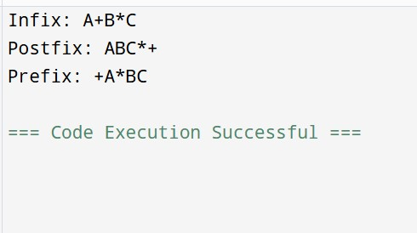
The git hub link is below:
https://github.com/francine933/infix-postfix-prefix-converter.git

